**Khan Academy Virtual SAT online class**

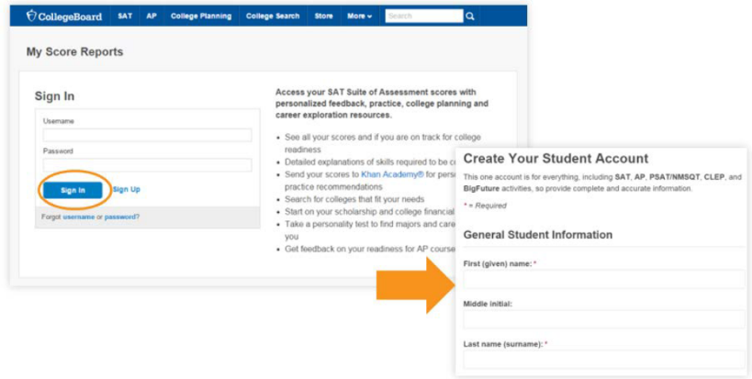**Sign up for College Board account**

1. Go to <https://studentscores.collegeboard.org/>
   1. Click sign up
2. Fill in the information, be sure to use your full name so that scores can be linked correctly.
   1. Click Next
3. Check the four check boxes to confirm your info.
   1. Click Confirm

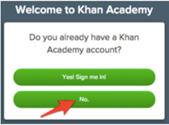

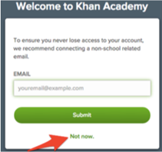**Logging into Khan Academy**

First time logging in will be ask if they want to link to an account.   
The answer is NO unless you already have a Khan account.

Students can choose to skip the next question, unless they would like to add a backup email.

**Option #1 (works best at school)**

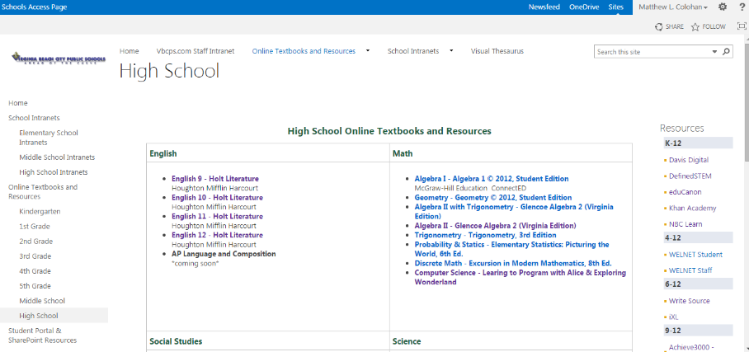SharePoint Student Portal -Online textbook and Resource page.  
<https://schools.vbcps.com/OLTextbooks/Pages/HighSchool.aspx>

* Click on Khan Academy under Resources (on the right)

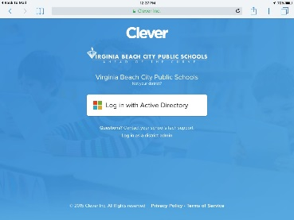**Option #2 (works at home or mobile device)**

Clever Dashboard - <https://clever.com/in/vbcps>   
*students may have to type in their school name

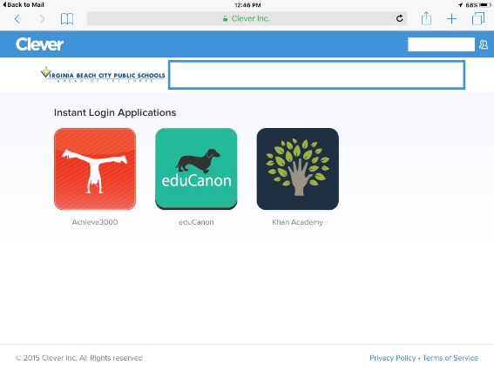Click on “Log in with Active Directory”

Students will enter their normal   
computer user name and password

Click on the Khan Button.

**Starting SAT Pep and Sharing College Board Scores with Khan Academy**

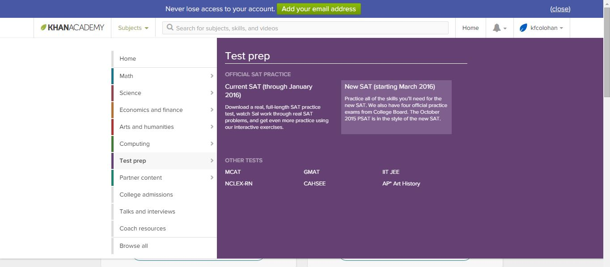

1. Click on Subjects at the top
2. Choose Test prep
3. Choose New SAT

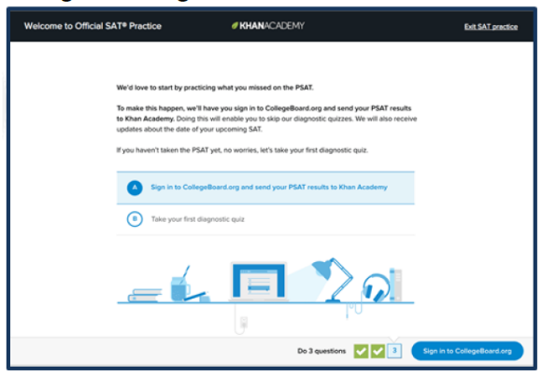

1. Enter Zip Code or skip
2. Select Option A “Sign in to College Board.org and send your PSAT results to Khan Academy”
   1. Students who do not have PSAT scores will choose option B to take diagnostic quizzes.
3. Select ONWARD
4. Students will be taken to College Board to sign in
5. 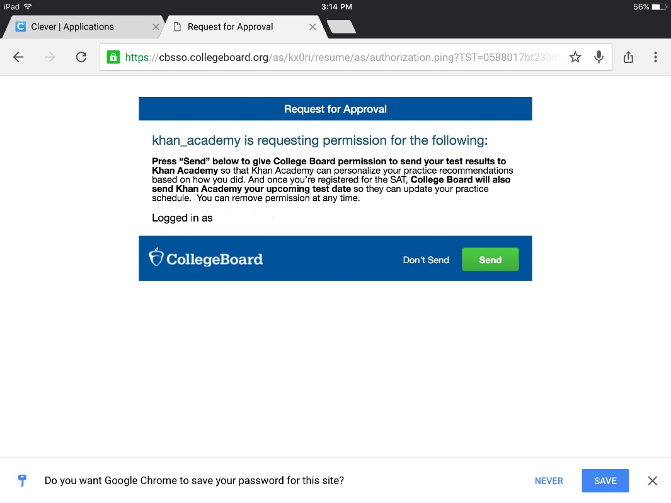Select SEND to Request for Approval
6. College Board will return students to Khan Dashboard
7. From the Dashboard, start working.

